Decision No. R24-0288-I
BEFORE THE PUBLIC UTILITIES COMMISSION OF THE STATE OF COLORADO
PROCEEDING NO. 23AL-0635G
IN THE MATTER OF ADVICE LETTER NO. 133 FILED BY COLORADO NATURAL GAS, INC. TO ELIMINATE THE CONSTRUCTION ALLOWANCES, TO BECOME EFFECTIVE APRIL 29, 2024.
interim decision OF
ADMINISTRATIVE LAW JUDGE
CONOR F. FARLEY
SCHEDULING REMOTE
PREHEARING CONFERENCE
Mailed Date: April 30, 2024

STATEMENT

Relevant Background
- On December 29, 2023, Colorado Natural Gas, Inc. (CNG) filed Advice Letter No. 133 with modified tariff sheets addressing the Service Lateral Connection and Distribution Main Extension Policy within its Rules and Regulations for Natural Gas Service effective April 29, 2024.
- On January 26, 2024, the Commission issued Decision No. C24-0061, which suspended the tariff sheets filed with CNG’s Advice Letter No. 133 for 120 days, through August 29, 2024, set the matter for hearing, established an intervention period through February 23, 2024, waived the December 31, 2024 deadline in Commission Rule 4210(d) pursuant to Commission Rule 1003(a), and referred the proceeding to an Administrative Law Judge (ALJ). The proceeding was subsequently assigned to the undersigned ALJ.
- On April 29, 2024, the ALJ issued Decision No. R24-0286-I that, among other things, established a schedule for the proceeding.
- The parties have proposed to amend the schedule adopted in Decision No. R24-0286-I.

Remote Prehearing Conference
- It is appropriate to hold a remote prehearing conference in this proceeding. Accordingly, a remote prehearing conference shall be scheduled for May 2, 2024 at 11:00 a.m. The remote prehearing conference will be conducted over the Zoom videoconferencing platform. The ALJ or a member of Commission Staff will email the log-in information in advance of the hearing.

ORDER

It is Ordered That:
- A remote prehearing conference is scheduled as follows:
DATE: May 2, 2024
TIME: 11:00 a.m.
WEBCAST: Commission Hearing Room
METHOD: Join by video conference using Zoom at the link to be provided in an email from the Administrative Law Judge OR Commission Staff
- Nobody should attend the hearing in person.
- This Decision is effective immediately.
(S E A L)    ATTEST: A TRUE COPY  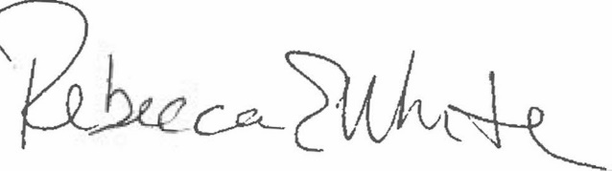  Rebecca E. White,  Director | THE PUBLIC UTILITIES COMMISSION  OF THE STATE OF COLORADO  CONOR F. FARLEY  ________________________________  Administrative Law Judge

4 Code of Colorado Regulations (CCR) 723-4.
4 CCR 723-1.
Additional information about the Zoom platform and how to use the platform are available at: https://zoom.us/. All are strongly encouraged to participate in a test meeting prior to the scheduled hearing. See https://zoom.us/test.

