Decision No. R20-0243-I
BEFORE THE PUBLIC UTILITIES COMMISSION OF THE STATE OF COLORADO
PROCEEDING NO. 19AL-0687E
IN THE MATTER OF ADVICE LETTER NO. 1814 filed by PUBLIC SERVICE COMPANY OF COLORADO TO implement the modified residential
energy time-of-use schedule to become effective january 2, 2020.
interim decision OF
ADMINISTRATIVE LAW JUDGE
CONOR F. FARLEY
AMENDING interim DECISION
no. R20-0202-I TO PROVIDE REVISED
INSTRUCTIONS FOR PARTICIPATING
IN the REMOTE PUBLIC COMMENT HEARING
Mailed Date: April 10, 2020

TABLE OF CONTENTS
I. BY THE COMMISSION 2
A. Statement 2
B. Instructions for Participating in Remote Public Comment Hearing 2
1. Instructions for Participating by Telephone 3
2. Instructions for Participating by Computer 3
3. General Instructions 9
4. Instructions for Observing the Public Comment Hearing 9
5. Written Comments 10
II. ORDER 11
A. It Is Ordered That: 11

BY THE COMMISSION

Statement
- A more comprehensive summary of the background of this proceeding is included in Decision Nos. C19-1015 and R20-0202-I. The facts relevant to this Decision are stated below.
- On March 27, 2020, the undersigned Administrative Law Judge (ALJ) issued Decision No. R20-0202-I that, among other things, scheduled a remote public comment hearing for April 16, 2020 and provided instructions for participating in that remote public comment hearing.
- Subsequently, the instructions for participating in the remote public comment hearing have been revised. The following are the revised instructions for participating in the remote public comment hearing scheduled for April 16, 2020. Members of the public and the parties to this proceeding should NOT use the instructions in Decision No. R20-0202-I, but instead should follow the instructions in this Decision.

Instructions for Participating in Remote Public Comment Hearing
- The Commission prefers written comments over oral comments. As a result, the Commission urges individuals to provide their comments in written form via the methods described in more detail below on page 9.
- For those individuals who nevertheless want to provide oral comments, the Commission uses the web-hosted video conferencing service, GoToMeeting, to hold video conferences, and in this case, a remote public comment hearing. Individuals who wish to provide public comments during the public comment hearing can participate and provide their comments either by telephone or computer. The following are general instructions for how to participate by telephone or by computer.
- Additional information and tutorials for using GoToMeeting are available at:
https://www.gotomeeting.com/meeting/resources/gotomeeting-quick-and-helpful-guide-for-attendees.

This link is only provided for the convenience of the individuals who plan to participate in the remote public comment hearing, and is not intended to guarantee that the information on the link is accurate or that it provides all the information the parties may need in order to use GoToMeeting. Those individuals who plan to participate in the remote public comment hearing by computer are strongly advised to familiarize themselves with GoToMeeting before the hearing.

Instructions for Participating by Telephone
- Any member of the public or party who wishes to provide comments by telephone during the remote public comment hearing must call 224-501-3412 when the hearing takes place. When prompted, input 117041237#. You will then be placed into the public comment hearing. Please note that your session and participation will be controlled by the ALJ/Commission Staff.

Instructions for Participating by Computer
- Any member of the public or party who wishes to participate in the
public comment hearing by computer must use a computer that is connected to the
- internet and has a microphone and a speaker. At the time of the hearing, please go to https://global.gotomeeting.com/join/117041237. The webpage below will appear.
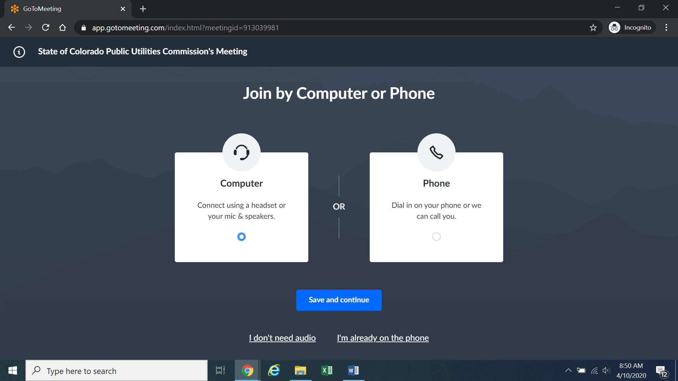
Confirm your audio settings and click “Save and continue.” Note: You may be prompted to allow the session to access your microphone and/or camera. Finally, you will be prompted to enter your name for identification during the session:
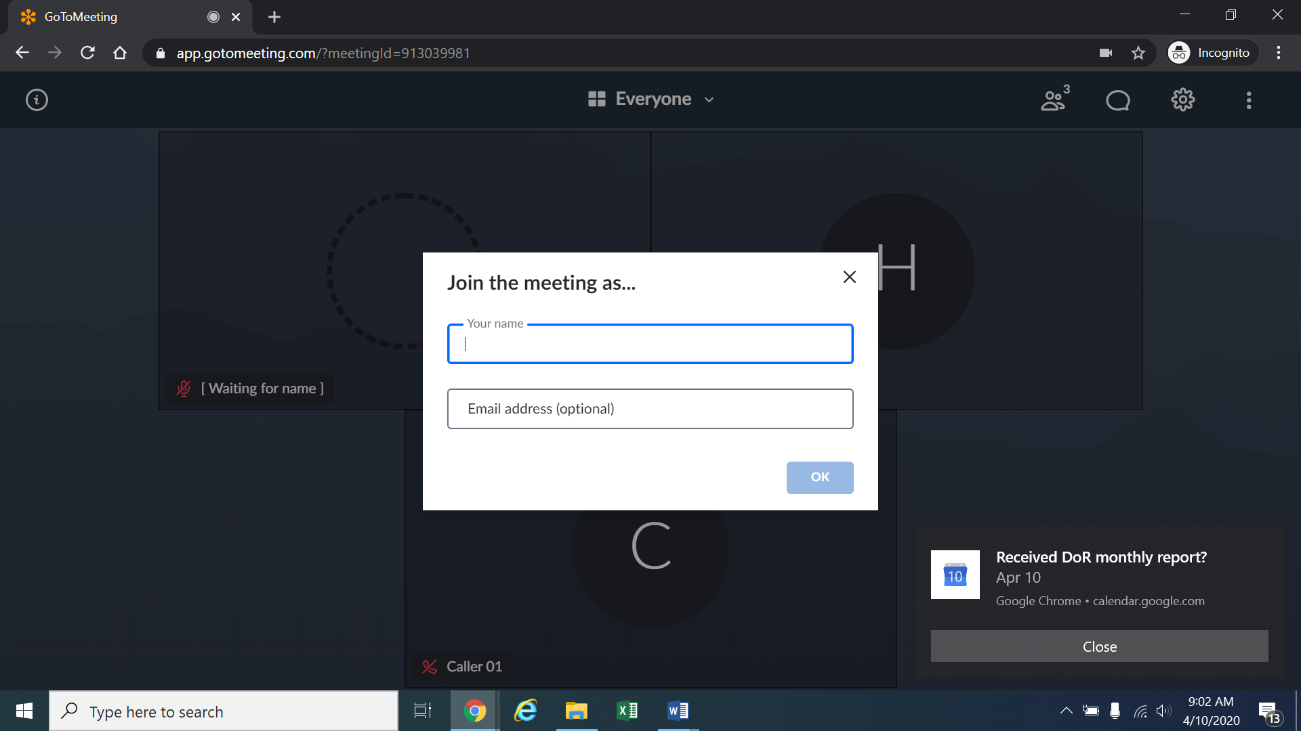
Alternatively, if there is any problem with the link provided above, please go to https://app.gotomeeting.com/home.html and enter 117-041-237, which is the Meeting ID/Access Code, to join the meeting.
- If you do not want others participating in the hearing to see you, please click on the camera icon contained in the green circle at the bottom of the video screen. The icon will turn white and a slash will be placed over the camera icon indicating that your camera has been turned off. Likewise, if you do not want others participating in the hearing to hear you, confirm that there is a slash over the microphone icon contained in the red circle indicating that your microphone has been turned off. In the screenshot of the webpage below, the microphone is turned off while the camera is turned on.
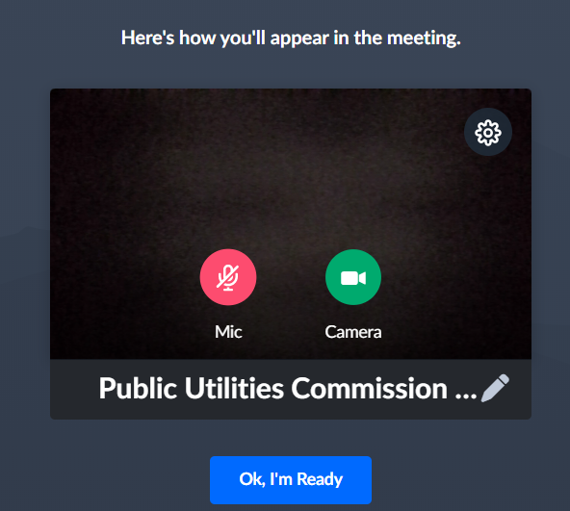
Conversely, the screenshot of the webpage below shows the microphone and video icons turned on and are ready to transmit video and audio when you join the hearing.
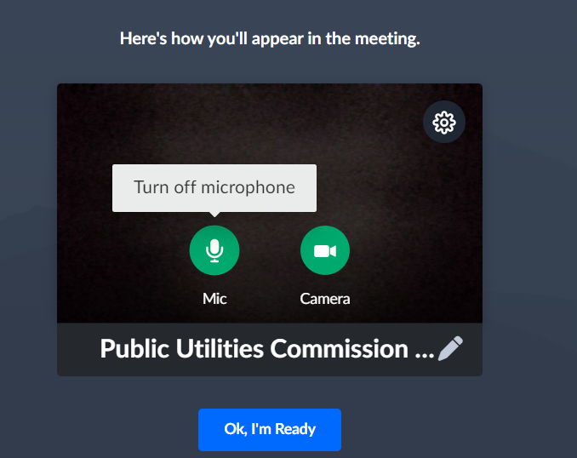
- When you have the video and microphone settings the way you want them, please click “Ok, I’m Ready” in the blue box (shown in the screenshots above) to join the meeting.
- You can control the volume of the audio through the volume controls on your computer. The screenshot below shows the screen after joining the hearing with the camera turned on and the microphone turned off.
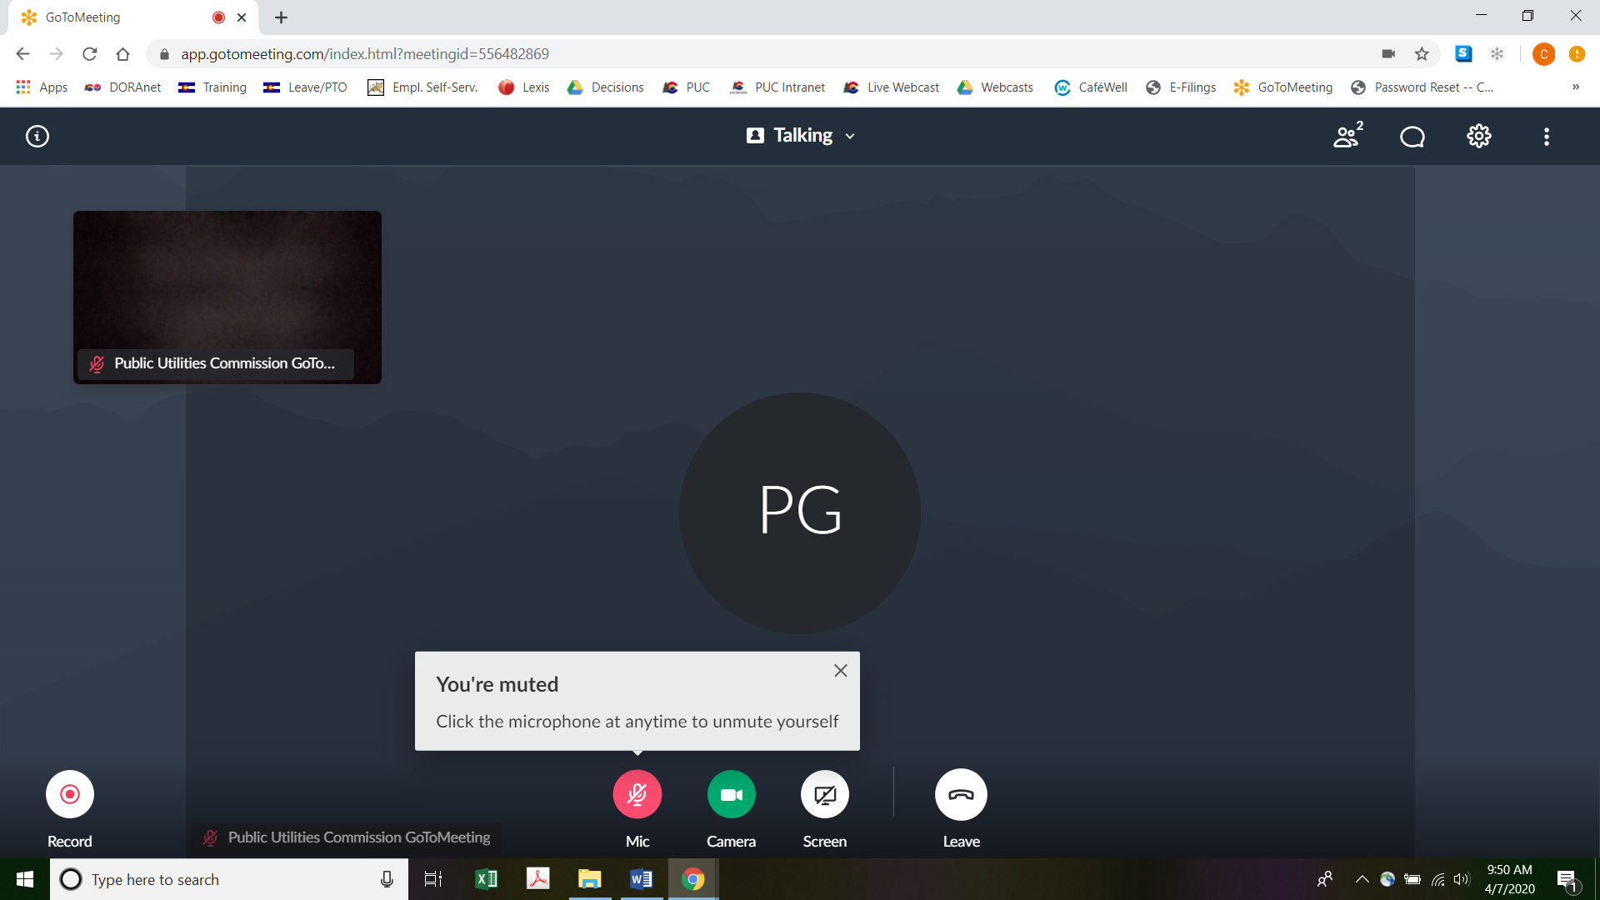
- All participants in the hearing should mute (turn off) their microphones during the hearing until called upon by the ALJ to provide comments. When prompted by the ALJ to provide comments, please click on the microphone icon to turn on your microphone and then commence speaking. The red circle around the microphone icon will turn green indicating that your microphone is turned on. While you are speaking, please listen for any direction you are given by the ALJ.
- To terminate your participation in the hearing, please click on the telephone handset icon with the word “Leave” underneath it and then click the “Yes” button in the pop-up box, or the “Not now” button if you would like to stay in the meeting, as shown in the screenshots below.
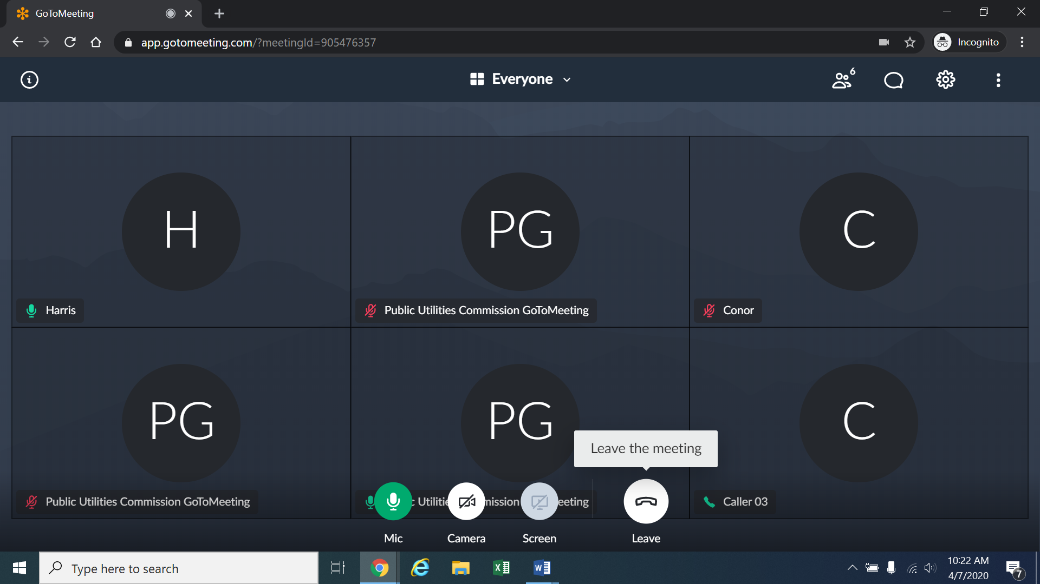
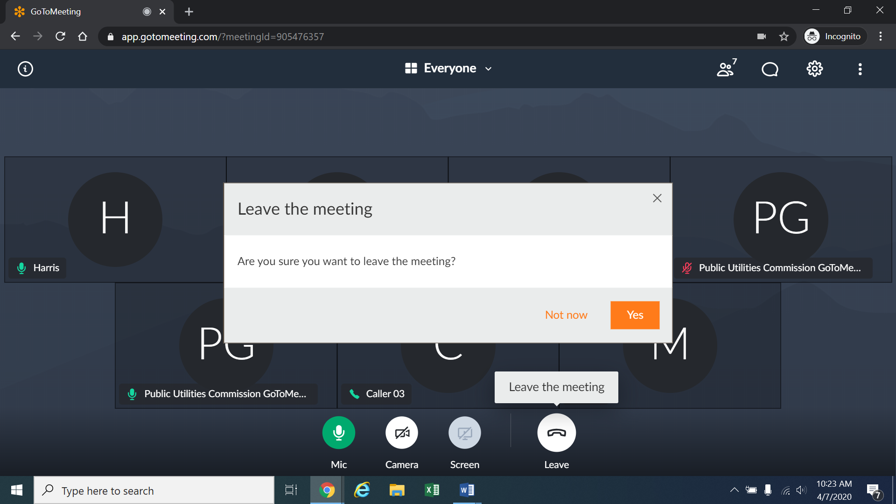

General Instructions
- The following are the procedures for the public comment hearings:
a) An individual who is a party or who is a representative of a party will not be permitted to present comments at the remote public comment hearings. Parties will present their positions and will make their comments through testimony at the evidentiary hearing.
b) The remote public comment hearing will be transcribed.
c) The remote public comment hearing will begin at 4:00 p.m. and will continue until concluded, but in no event later than 6:00 p.m.
d) At the outset of the remote public comment hearing, the ALJ will ask for those members of the public who wish to provide public comments to identify themselves. The ALJ will then call on each individual to provide his/her comments. Generally, the ALJ will permit each individual to speak for five minutes, but the length of time allotted to each speaker will depend on the number of persons who wish to speak.
e) The ALJ may ask clarifying questions of an individual who makes a comment at the public comment hearings.

Instructions for Observing the Public Comment Hearing
- If you do not wish to speak but would like to listen to the public comment hearing, please do not participate by telephone or computer as described above. Rather, please go to https://puc.colorado.gov/webcasts. The following webpage will appear.
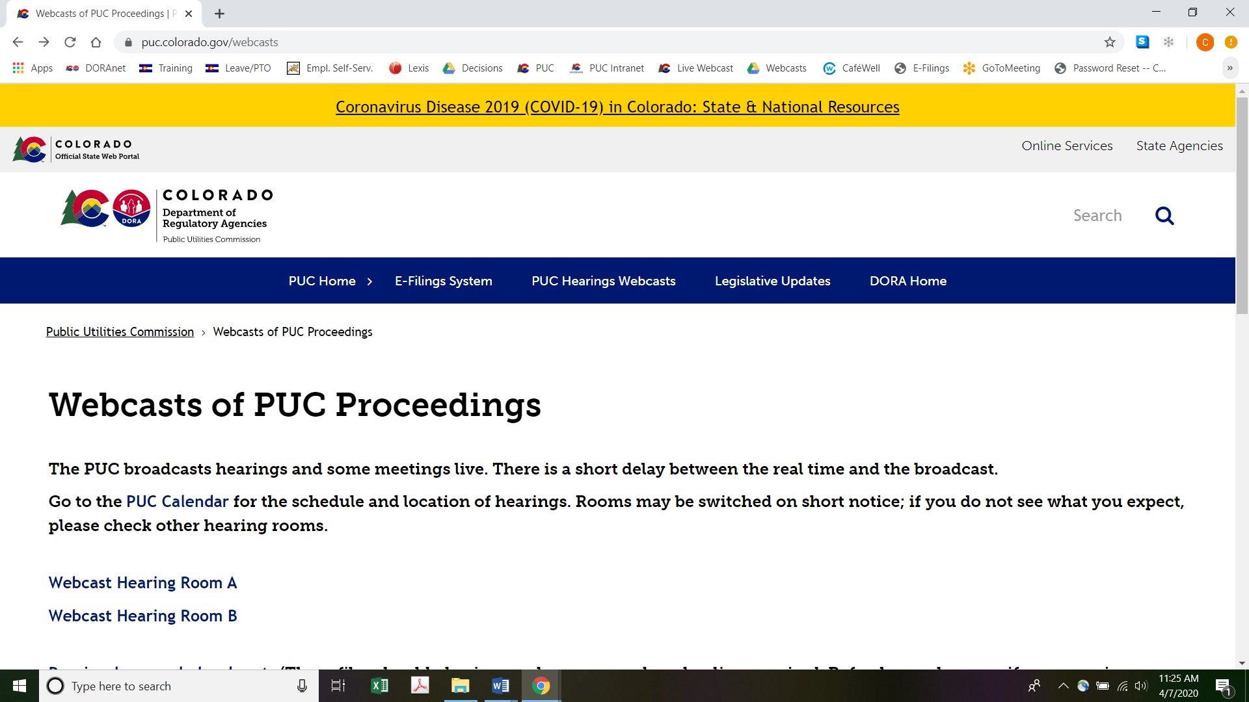
Please select the hearing room (“Webcast Hearing Room A” or “Webcast Hearing Room B”) listed for the public comment hearing on the Commission’s public calendar, available at https://puc.colorado.gov/puccalendar. Once the hearing room is selected, please click one of the “audio only” links if using a mobile device (e.g., “Hearing Room A Audio Only (IOS)” or “Hearing Room A Audio Only (Android/Other)”), or click the play button on the black screen, to stream audio of the hearing live (with a short delay between real time and the broadcast, as noted in the screenshot above).

Written Comments
- The Commission prefers written comments over oral comments. As a result, interested persons are encouraged to submit written comments through either: (a) the Commission’s Electronic Filing System at https://www.dora.state.co.us/pls/efi/EFI.homepage in this proceeding; or (b) the Commission’s website at https://puc.colorado.gov/ by clicking on the “FILE A COMMENT OR COMPLAINT” link. Both oral and written comments will be given the same weight in this proceeding.

ORDER

It Is Ordered That:
- A remote public comment hearing is scheduled for April 16, 2020. It shall take place from 4:00 p.m. until it is concluded, but not later than 6:00 p.m. Members of the public who wish to participate in, and/or to provide public comments at the remote public comment hearing, must follow the instructions stated above. Members of the public should not follow the instructions for participation in Decision No. R20-0202-I that issued on March 27, 2020. Members of the public should not attend the public comment hearing in-person.
- This Decision is effective immediately.

(S E A L)    ATTEST: A TRUE COPY  Doug Dean,  Director | THE PUBLIC UTILITIES COMMISSION  OF THE STATE OF COLORADO  CONOR F. FARLEY  ________________________________  Administrative Law Judge

Decision No. C19-1015 was issued in this proceeding on December 18, 2019.
To minimize audio feedback, you are encouraged to listen using headphones connected to the audio/headset jack on your computer.

