Decision No. R25-0363-IE
BEFORE THE PUBLIC UTILITIES COMMISSION OF THE STATE OF COLORADO
PROCEEDING NO. 25G-0167TO
COLORADO PUBLIC UTILITIES COMMISSION,
COMPLAINANT,
V.
ahmed koon in his capacity as owner and/or operator of 24/7 recovery and towing llc,
RESPONDENT.
errata notice for
INTERIM DECISION
scheduling REMOTE hearing AND ESTABLISHING PROCEDURES
Errata issued: June 30, 2025
Original Decision issued: May 14, 2025
- Attachment B to Decision No. R25-0363-I issued on May 14, 2025 was not the correct attachment.
- Attachment B to Decision No. R25-0363-I is attached to this Notice.
(S E A L)    ATTEST: A TRUE COPY  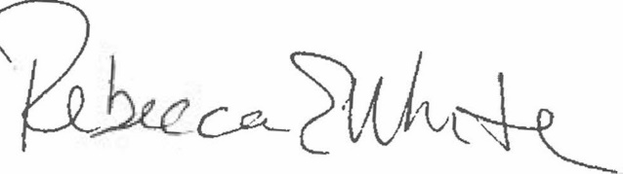  Rebecca E. White,  Director | THE PUBLIC UTILITIES COMMISSION  OF THE STATE OF COLORADO  KELLY A. ROSENBERG  ________________________________  Administrative Law Judge

